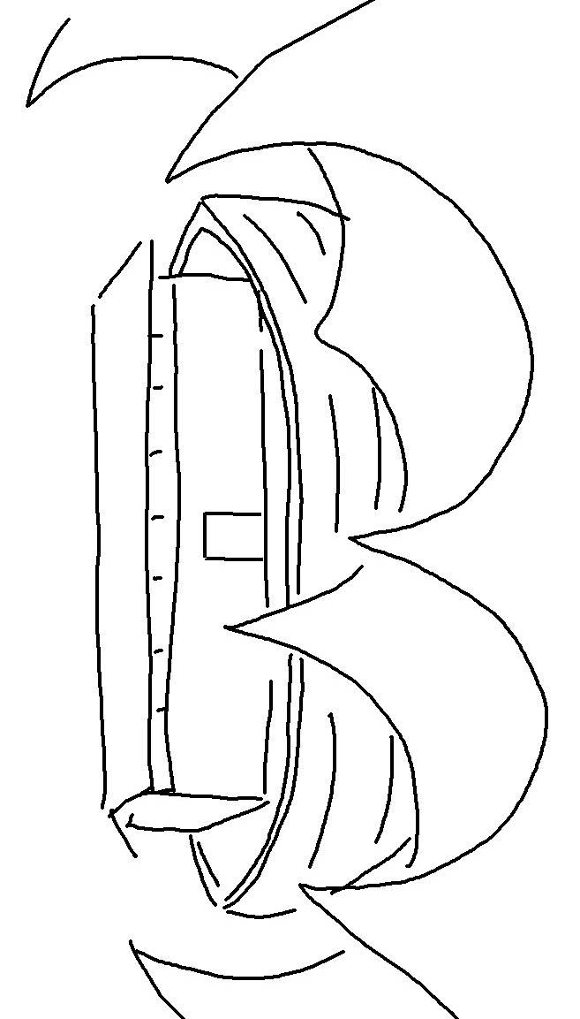
E _ _ _ _ _ _ _ who calls on the name of the _ _ _ _ will be _ _ _ _ _.Romans 10:13_{NLT}

